**Order Team New Website Description**

**Important:**

**Speed** is the key, should not be taking seconds or minutes to download on each and every step and page - it is counter productive

**There should be 0 extra verification notifications**; asking do you want to do this, are you sure, should not be popping up. Magento has too many of these popping up notifications. It is acceptable only when we click on order cancelation. Other than that it is total waste of the clicks and time.

For Order Team tasks the **old website is the ideal website**. Please make sure to include everything from the old website back end, and there should be no customer complaints at all then. Please include all the aspects and features of old website to avoid customer complaints as the old website was working perfectly well for customers and the order team.

New ideas and points have been highlighted in Blue colour.

**Automatic email notifications to the customers:**

Direct Order confirmations, online order acknowledgements, cancellation, hold/ pending notifications to the customer should be sent as email body, however, invoices should be automatically sent as PDF directly to the customers when we click on invoice.

Order Confirmations should be linked to [order@abmgood.com](mailto:order@abmgood.com) so that order team knows what we actually sent to the customer, just in case customer has any weird inquiries later on.

e.g. order confirmation

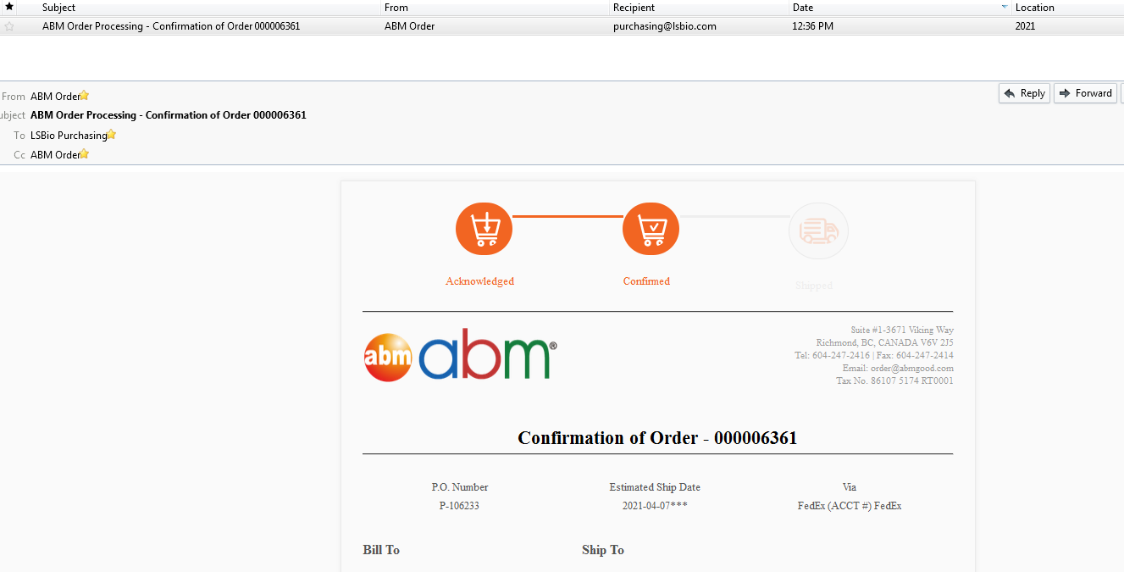

e.g. first online order acknowledgement and then later order confirmation when order team confirms the order.

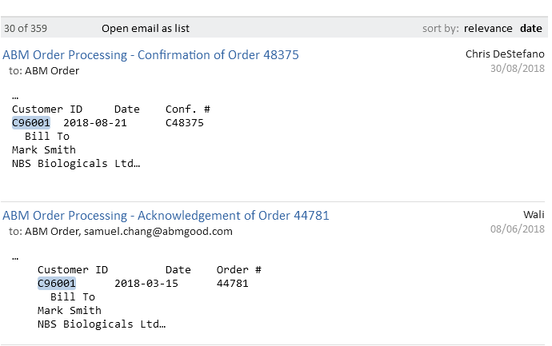

Customer should receive an automatic notification when the order is cancelled, put on hold or pending. Customer should receive an automatic email notification as “status update”, when the order is cancelled, put on hold, put in pending or placed in deposit folder, showing any updated notes for the customer as well.

e.g. Order Cancelled Notification

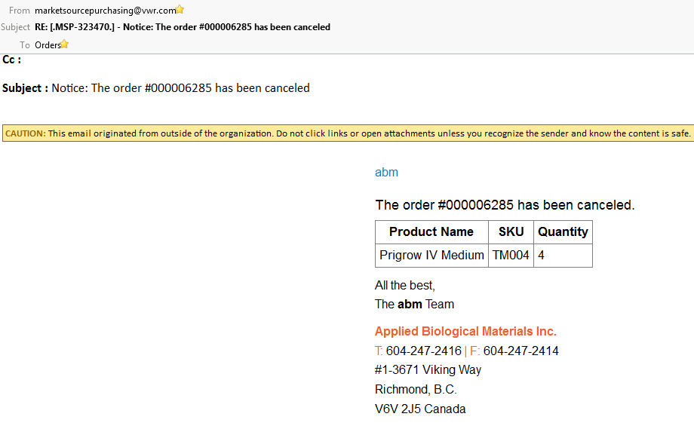

e.g: Order Pending Notification

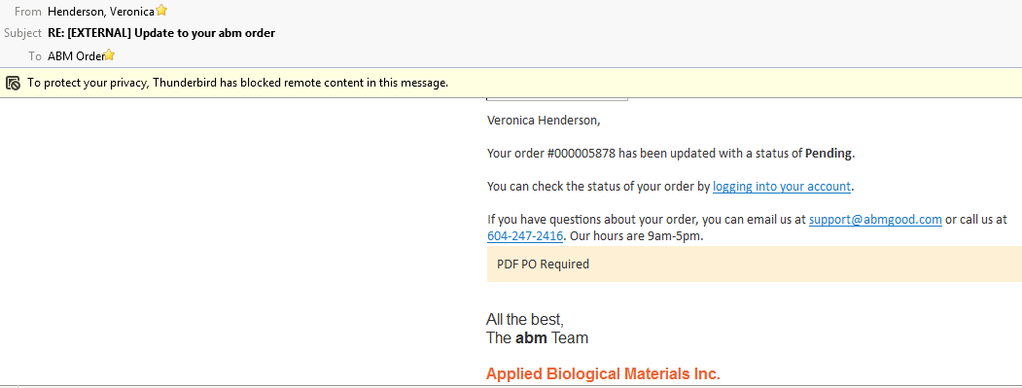

### Quotations

There should be direct option on ordering page to make it a quote or check out and turn into an order

e.g.

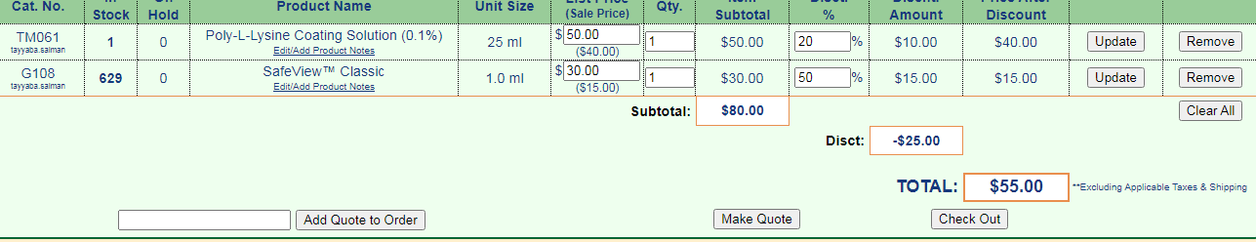

We should be able to remove/ add items and change pricing, quantities, discounts, notes, expiry date on the quote later at the quote level and also at the time of ordering when we pull the quote into the cart.

Order team members should not be waiting for others to generate the catalog numbers to enter in the system prior to placing the orders like Magento. We should be able to customize the catalog numbers and item description both at the order and the quote level and everyone placing the order should be able to enter the catalog number.

e.g.

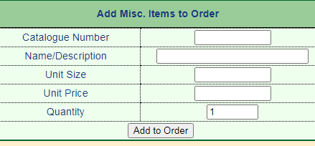

Customer contact information page should be simple and clear including all of the following:

e.g

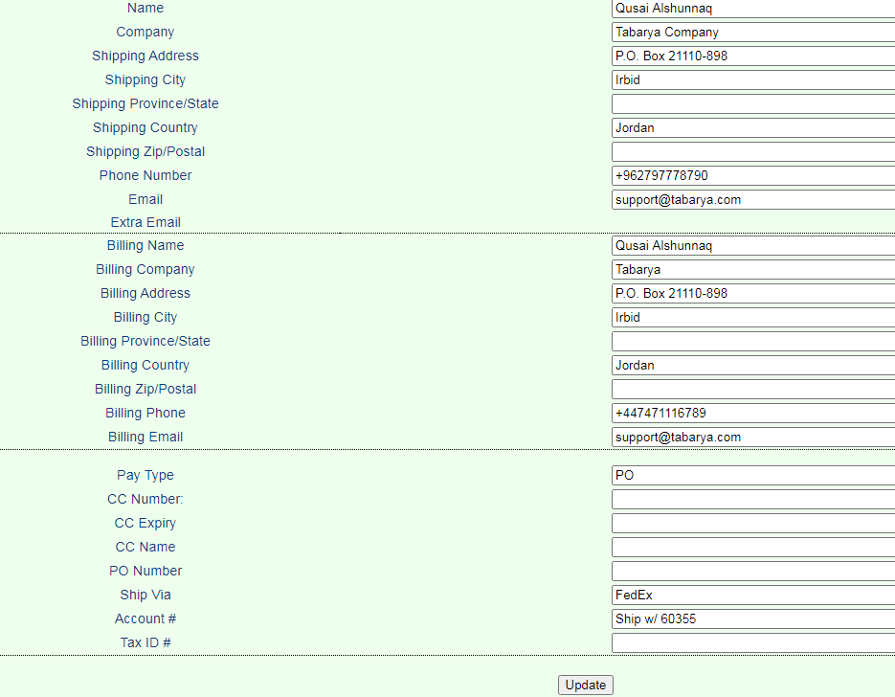

We should be able to add multiple emails with the comma, colon or semi colon so that multiple people can receive the order confirmation or invoices.

e.g.



There should also be a tab to make any changes in the account information, order contact information and to review the CSL.

e.g.



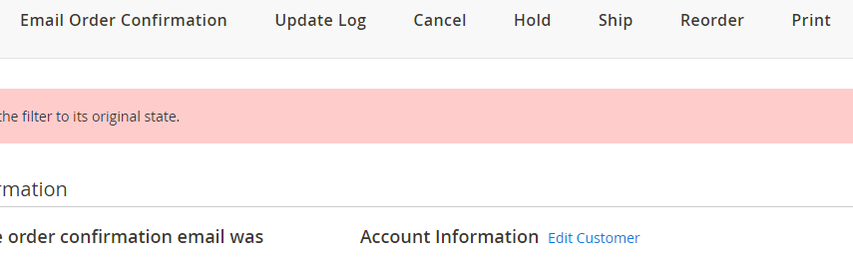

For the address line, we should be able to generate multiple line address for printing by using HTML <br> or by having multiple lines option at the time of order placement.

Order processing date, confirmation date, estimated shipping date, shipped date and invoice date should be showing for quick reference.

e.g.

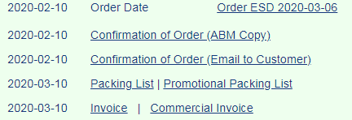

Order should be marked paid and complete clearly.



Order team should have tabs to access to hold/unhold, complete/not complete, cancel, pending/not pending the orders for easy and effective management.

e.g.

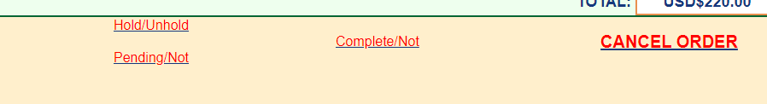

**Locating Existing Quotes**

We should be able to Search using the quote number OR

Use the filter search function and enter in the customer’s email to pull up a list of quotes generated for that particular customer OR

We should be able to enter the company name to pull up all the generated quotes for that company

Also, for distributors accounts there should be a system where we can enter the discounts and add the distributor account to the list and the system should grab the account name from the list, update the currency type and add the discount automatically just like the old website

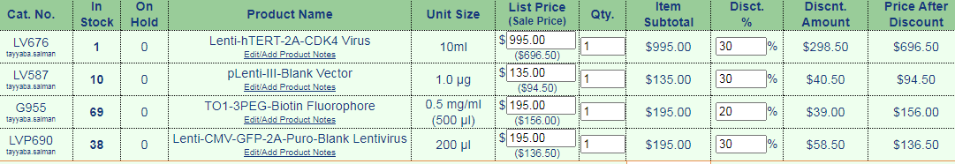

**Order placement**

Quotes and orders should have the option to change currency USD or CAD

While placing the orders, there should not be auto filling in the fields

At the time of order placement, we should be able to add several items at once to the cart with different quantities:

e.g.

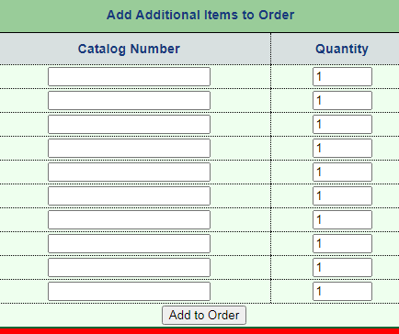

Items from the previous cart should not be added automatically to the current cart

It should have the ability to update the quantities and pricing of multiple items at once.

e.g.

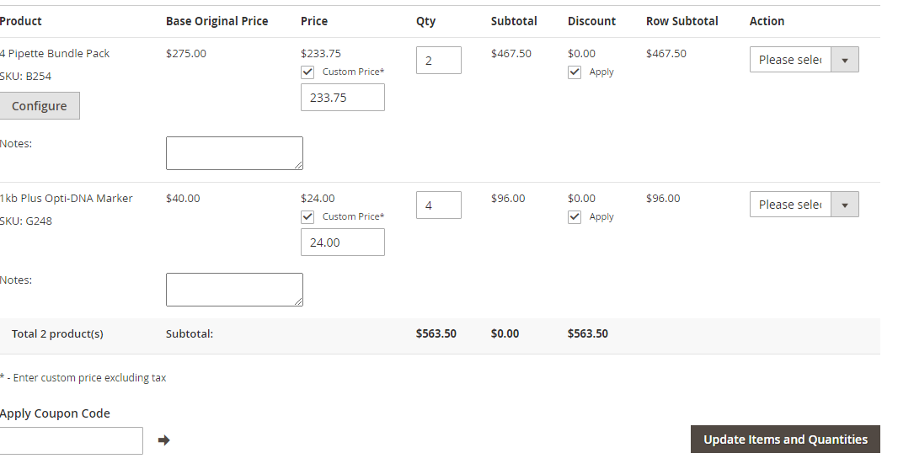

out of stock items shows yellow while placing the order

out of stock items shows red when order is placed

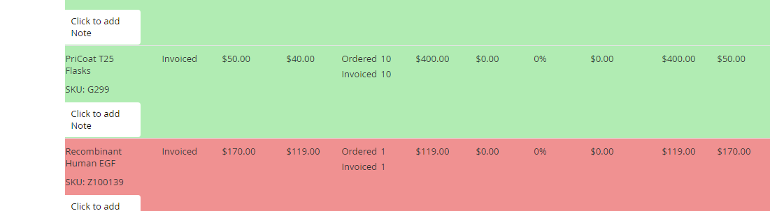

There should also be easy to use clear cart function:

e.g.

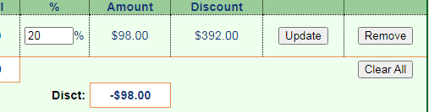

Promotional codes can be added and working, discounts should be added automatically

Fedex number should automatically pop up if already entered in the account information page

e.g. for distributors

Order placement accounts and accessing CC information should have individual personal sign ins

It should show all the orders according to the purchase date / order number sequence as the order list.

While entering the items to the cart, it should show how many quantities are in stock and on hold for quick reference.

e.g.

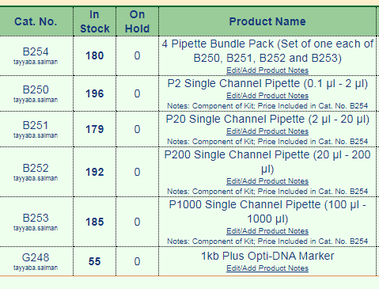

There should not be so much gap between the line items of an order like Magento. There should be only proper gap just like old website so there won’t be too much scrolling up and down.

## Order placement from a Quote

Once the order is placed from a quote, the order page should show the quote number.

Also, there should be deliverables, lead time, internal notes, external/customer notes/ shipping notes sections for each order which we should be able to change/update even later when the order is already placed from the quote.

### Order placement From a Purchase Order

We should be able to search the orders by the PO number to avoid duplication of the orders.

# Online Orders

International / US / Canadian pricing – it should detect the customer automatically where the customer is placing the order from and select the currency accordingly. Also it should automatically calculate the conversion i.e. 1.5x for International orders and 1.15x for Canadian orders.

There should be a box where customers can enter their notes or messages they want to convey to the customer service/ order team, if any

Customer should receive an automatic acknowledgement email notification once the order is placed online. This should be separate from the order confirmation, usually sent once the order is confirmed by the order team

When the order is placed online the customer should have an option to enter their FedEx account number or leave it blank for the abm team to add the shipping.

Order team should be able to add the notes to the order. There should also be options to select if the customer should be notified or not.

## 

## Sample Orders

We should be able to enter the catalog numbers as sample-XXXXX

## Rewards Redemption Program

When the customer redeems their points, the Rewards Redemption Notifications should be sent to the customer as well as to the order@abmgood.com

We should be able to search Rewards Redemption Notification# or Redeem Order#

There should be “Loyalty Program List Index” and “Filters” options

The reward redemption order details should include the actual sales order number the points are being redeemed for. When we click on that sales order number, it should bring us from the redeem order to the actual sales order. The actual sales order should also have the tab to go to the redeem order for that specific sales order and vice versa. i.e. Reward points should be linked to the original Magento orders directly.

There should be a notes section in the redeem order to write the comments on.

Redeem order should also have customer main account number, shipping/ mailing address, contact number and email address.

Redeem order should also have the tabs ‘shipment’ and ‘complete’.

Reward point history should be searchable for a specific company/ institute/ customer name and/or their email address.

### Order Status

# Changing ESD and their tracking should be visible

Once the order status is changed, shipped, cancelled, hold, pending, paid the order in the order list should show in different color or tagged on order line.

e.g. shipped



e.g. marked paid





e.g. pending



e.g. hold



e.g. cancelled



# Order Cancellations

Cancel items automatic emails should be sent to the lab and the customer at the same time

# Tracking Shipments

There should be an automatic link to click on the tracking number provided on the order once it is shipped. This tracking number link should be able to direct the user to the Fedex / DHL/ Progrssive/ UPS website directly.

Once the tracking number is updated on the order and the shipment is submitted, the customer on file (ship to email address) should receive an automatic notification email.

**CSL Checking**

There should be automatic notifications emails sent to the order team on ESD

CSL should show all the comments by the lab personnel on the same page of csl when clicked from the order main page just like the old website

**Delayed & 3rd Level Alert Notifications**

Exactly after 1 month of order placement, order team and the responsible lab personal should receive an automatic email notification that the order is 1 month old now.

So the lab can response and provide the new estimated date to provide it to the customer. Also it will be helpful in getting the orders ready in time.

e.g.

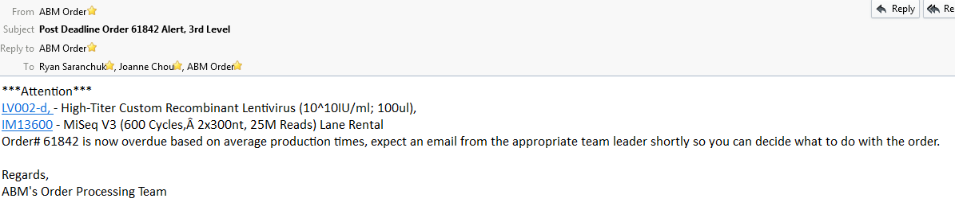

**Concord MTA**

There should be a link to see the MTA on Concord . We should be able to click on that link and that linkn should take us to the relevant MTA for that order to viw the MTA on concord from the new website main order page instead of going to the concord each time and logging in separately.

Cell lines should have clear link, highlighted MTA requirements and propagation instructions like old website

**Search Functions**

We should be able to search the orders by department folders.

e.g.

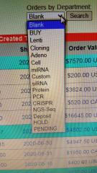

We should be able to search sales by the catalog numbers and products for a given period of time, when the search is pulled, should show the order number, then those order numbers should have a clickable link

There should be the option for product ship check

sales, shipped and daily reports should be searchable

Searching the orders by PO number, order number, invoice numbers should be possible

**Promotion Search**

Promotions page should be clear and it should have clicks and links to follow – easy to know the promotions of the products it is referring to. And it should also have links to bring the customer to the relevant products the promotion is covering.

e.g.



**Related/ Recommended Products Search:**

The products page should have the linked and recommended products option at the bottom of every page. It also should have back and forth links for the recommended products like the old website.

When any product is searched on the website main page, it should pull up all the products covering that one specific word in the search bar.

**Past Orders Search**

There should be a sales tab and we should be able to search the sales of the specific product catalog or product category for a given period of date and time.

e.g.

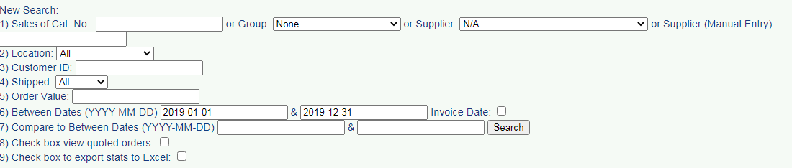

While pulling up the invoices, we should have the option to change the date at the time of printing (paper copy or PDF). At the same time, we should also be able to select and change payment terms on the invoice.

e.g

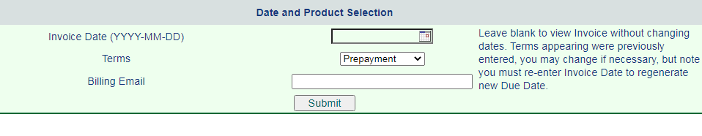

**Miscellaneous Searches**

There should be different tabs for different sections to go in and then further filters applicable for that search.

e.g.

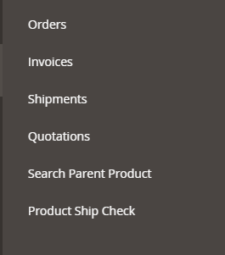

When we search a certain word for a particular company or university, we should be able to pull all related orders and invoices.

We should be able to pull up all the invoices related to a particular company, those invoices should have the order numbers linked to them.

We should be able to search all the orders for a particular company.

We should be able to search the orders via the PO numbers and/ or email address.

Order should have different folders and ESD to select and change

**Customer Account**

We should be able to make a new customer account.

Customer should also have the ability to create the new customer account and place the orders for themselves, once they place the orders online they would receive an automatic acknowledgement email and when the order team would confirm the order, the customer would receive an automatic order confirmation email.

We should have the tab and ability to delete customer account like Magento

Once the customer makes a new account, they should be receiving an automatic email with the account ID#, password reset procedure should be easy and simple to follow for the customer just like the old website.

Order team should be able to send the automatic email to the customer for password information.

Not confirmed orders should be tagged ‘Not Confirmed’ for easy and quick order team management.

e.g.

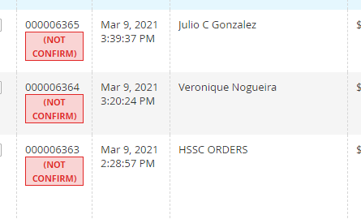

# ABM BOSS

ABM Boss system is a success, it should remain in place to change/ update/ delete the items and the orders and invoices according to the customer needs.

Or there can be tabs on the same order page to make the changes accordingly

If an item is removed from the order or added to the order, inventory should be automatically adjusted.

There should be a delete tab on already existing orders.

e.g.

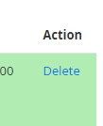

When an item is deleted, order notes should also show the records that it has been deleted.

e.g.



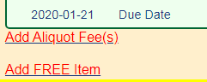

Customer Accounts should show the value of unpaid orders shipped to know the account balance.

e.g.





**Inventory Updates**

When the item is restocked they should automatically become Green. i.e. the line item which is restocked in inventory, should change the color from Red to Green.

e.g.

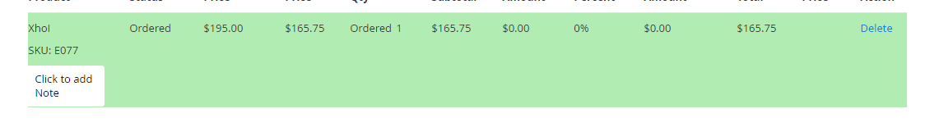

There should be product notes/ edit notes option for products on the order.

e.g.

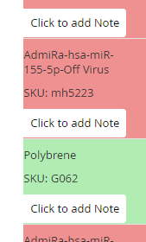



**Folder Assignment**

It should have the ability to put the orders on hold or pending, should able to differentiate between the two as we put the colour code the order line differently

When an electronic folder is selected for an order, it should be displayed on the order bar, so that we know in which folder/ department the order is.

If the order is out of the folder, it can be no folder showing.

e.g.

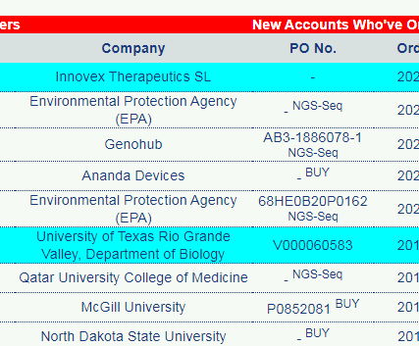

We should be able to search orders shipped, orders cancelled, orders marked completed.

We should be able to pull up the search for the orders placed for a certain time period shipped, completed, ready, not ready, pending, on hold, under deposit so that we can work efficiently and accordingly.

**Account Notes:**

In the customer account notes account information page, especially for the distributor accounts, there should be different sections for selling/ promotion rules, payment notes, shipping notes and after shipping sections so that we can look into the specific section quickly instead of going through all the account notes. The customer account notes should have the information in the HTML format so we can highlight, color code, make them underlined or bold according to the level of importance.

Also, the account notes/ notes should be at the bottom of the page just like old website, not on the side like Magento as sometimes the account notes/ instructions are so long that for every order we have to scroll up and down.

e.g. Cosmo and ITSBio Accounts

**Order notes**

Account notes should be updated to the new accounts automatically for the same company or institution name.

There should be 2 boxes on account information page, not visible to the customer:

1 – Alert Notes, should be highlighted in Red/ yellow

2 – Account notes, for the detailed notes about the customer account

**Invoices and packing lists/ shipments:**

Once the order is shipped, invoice should be sent automatically to the billing email address for Net30/ PO orders so there is no delay in invoicing and we can start counting the Net30 terms from that date.

If the invoice is not paid, the system should automatically send a reminder email to the billing email address stating that the invoice is past due.

## Once the order is marked paid, there should be tab for finance to send the notification email to order team, just like the lab does on CSL

The system should also have the ability to give us the option if we want to print the invoice in PDF or Word.doc

Invoice number should be same as order number just like the old website to avoid confusions

Invoice date should match with shipping date when pulling up for the invoicing list just like the old website

We should be able to make split invoices and split packing lists like Magento

Invoice should have the a comment box where finance can write down the date and amount of payment received, also the cheque number.

Credit memo should also be linked to the order, if any, just like Magento

There should be tab for generating and submitting invoices, also to send the PDF copy of the invoice directly to the customer

There should be a link for invoices, credit memos and shipments on each order.

e.g.

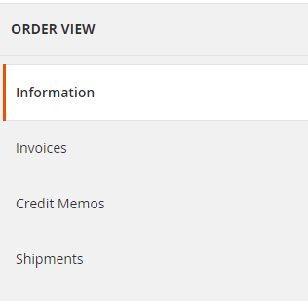

Packing List should have the ability to be pulled up as Packing Lists with the options of all or partial orders selection. Nice and simple, straightforward.

e.g

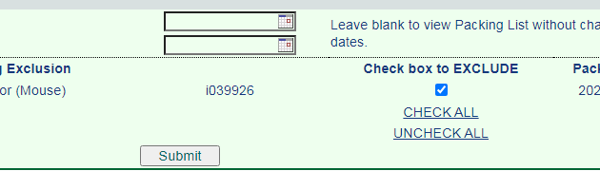

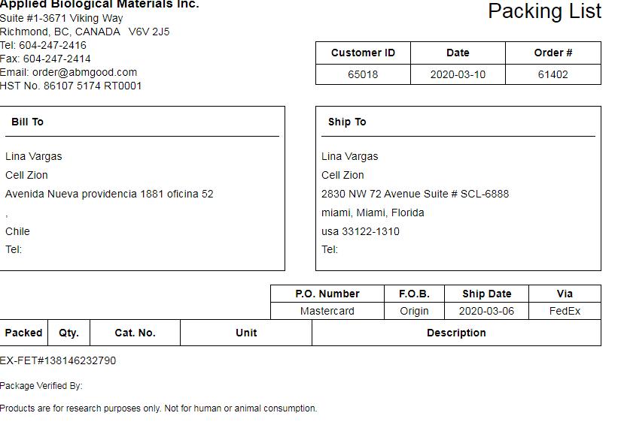

Invoices and packing list should clearly mention at the bottom;

Note: US customers may be subjected to an additional FDA inspection fee for cross-border delivery.  
Products are for research purposes only. Not for human or animal consumption.

Invoice should automatically change the name to receipt or marked paid in full once marked paid.

e.g.





Invoice should automatically calculate the Taxes, if applicable.

Invoice should show if any amount is credited to the order.

Invoice should show the due amount on the order.

When any changes are made to the order, invoice and inventory should automatically capture the change. Also, this change should be automatically emailed to Finance department and Inventory change should be automatically emailed to the relevant lab or inventory person.

Invoice should show our address as Remit to address, including [order@abmgood.com](mailto:order@abmgood.com) email and our phone number.

e.g.

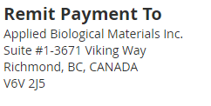

Invoice should show Invoice date, Invoice number and corresponding order number.

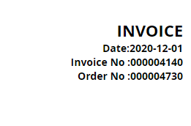

On the invoices, there should be separate lines for Shipping, GST, PST, Bank Fee, so they can be separate and customer clearly understands them.

e.g.

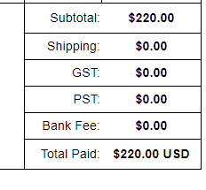

Invoice should have a due date section and the payment method section.

e.g.

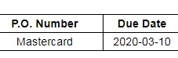

Invoices should have Ship to, Bill to, Tax ID#, customer contact number, email address and Courier information clearly mentioned on the invoice.